1 - Approaches to human cognition

**Cognitive psychology**: concerned with the internal processes involved in making sense of the environment and deciding on appropriate action. The aim of cognitive psychology is to understand human cognition by observing the behaviour of people performing various cognitive tasks. Our ability to interact with the environment, use of empirical data to test theoretical or computational models

AI: its aim is to build something that does an intelligent job, intelligent process using advanced technology

Computational modelling: want to reproduce human behaviour (different from AI whose aim is just to produce something intelligent without caring too much about humans behaviour)

Human can fail to think effectively even on relatively simple problems

Mental action, process of acquiring knowledge and understanding through thought experience and the senses in order to engage goal-oriented behaviours. Help us to re-elaborate → information processing

Information processing: occurs in many stages, the internal mental process begin with the appearance of an external stimulus and result in a behavioural response

Cognitive psychology studies human information processing

Brain-imaging technique (fMRI)

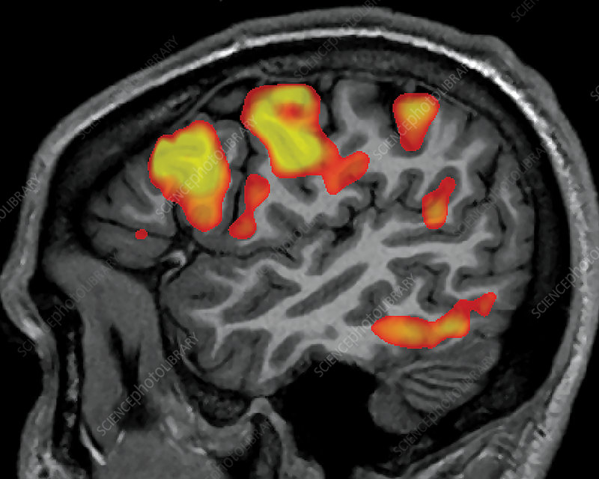

Also there is the electrophysiological technique involving the recording of electrical signals generated by the brain

# Four main approaches

4 main approaches to human cognition

1. *Cognitive psychology*. Using behavioural evidence to enhance (migliorare) our understanding of human cognition. Cognitive psychology influence is enormous. The way we try to understand how the human brain works, we select a specific task and specific condition, we make a prediction and we collect empirical data to see if our hypothesis is right. We don’t look at the brain activity, we study the behaviour
2. *Cognitive neuropsychology*. Studying brain-damaged patients to understand normal human cognition. Study brain-damaged people and we compare the results with people who have not any damage. Brain-damaged: people born with a disease, after an accident…
3. *Cognitive neuroscience*. Using evidence from behaviour and the brain to understand human cognition. We measure brain activity while doing a task
4. *Computational cognitive science*. Develop computational models to further our understanding of human cognition. A computational model takes the form of an algorithm (providing a specific set of steps to problem solutions) computational models are designed to simulate or imitate human processing on a given task. It uses computational models (algorithms) to understand cognition

# Cognitive psychology

First half of twentieth century there was the approach of behaviourism

John Watson (1878-1958) founder of behaviourism. Psychology should focus on stimuli (aspect of the immediate situation) and responses (behaviour produced by the participants in an experiment). Focus on stimuli and responses, both of which are observable

*“The brain is a black box, we can’t know what’s in there and we don’t care, slowly we started thinking about what’s in because we headed it*”

INFORMATION PROCESS APPROACH

It considers that humans processing is similar to a computer

BOTTOM-UP SERIAL PROCESSING

Serial: step by step

Processing inflated by environmental processing

Processing directly influenced by environmental stimuli

**TOP DOWN SERIAL PROCESSING**

Stimulus processing that is influenced by factors such as the individual's past experience and expectations

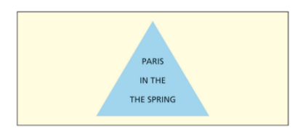

There are two “the” but we read only one

Processing is parallel, it isn’t serial, we do many things at the same time. Especially for well practised tasks. We are more likely to use parallel processing when performing a highly practised task than a new one

Cascade processing:

Later processing stages start before earlier processing stages have been completed when performing a task. Is a form of parallel processing involving an *overlap* of different processing stages. We start the first step as in serial processing but we start the second one even if we haven’t finished the first yet

Problem → impurity problem

Miyake used three tasks requiring deliberate inhibition of a dominant response:

1. *Stropp task*. Name the colour in which colour works are presented. 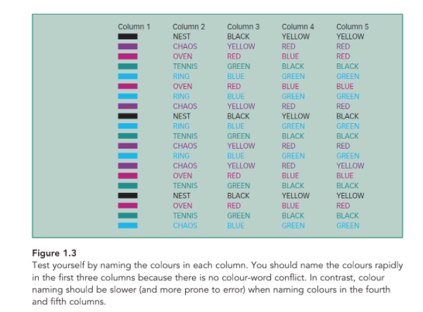
2. *Anti-cascade task*. Inhibit natural tendency to look at a visual cue (segnale) and instead look in the opposite direction
3. *Stop signal task*. Respond rapidly to indicate whether each of a series of words in an animal or a non-animal

**Strengths**

* Past systematic approach, without the others aren't viable
* It leads to theories and approaches
* Is flexible it can be applied to
* Double dissociation provide evidence for modularity
* Causal inferences relating brain atras process to behaviour can be drawn
* Powerful finding permit falsification or plausible theories or suggest more complete theories
* Limits cognitive psychology and cognitive neuroscience

**Limitations**

* cognitive tasks are impure and some lack. Ecological validity (experiments are done in labs, not in real life)
* Indirect evidence of understanding process
* Vague and hard-to-test theories
* Modularity and anuversality assumptions are too strong
* Brain damage always affect several modules also do the changes in connectivity
* Patients develop compensatory strategies from gerar to specific process
* De-euphasis brain pleasirt
* It’s hard to generalise due to individual differences

**Cognitive neuropsychology**

It focuses on the patterns of cognitive performance (intact and imparied) of brain-damaged patients having a lesion (structural damage to the brain caused by injury or disease)

Cognitive neuroscience: studies how the brain works while we’re doing different tasks

At the beginning if focused on HIP, recently it has strong connections to cognitive neuroscience

* Brain imagine
* Studies the impact of brain damage on brain behaviour

**Key assumptions** (ipotesi chiave)

1. *Modularity.* (functional), different functions are in different areas. Very limited interaction among modules. Each cognitive module is located in a specific brain region. Each domain respond only to one given class of stimuli
2. *Anatomical modularity*. Each module is located in a specific brain area. If all models were distributed across a large brain area then the great majority of brain-damaged patients would suffer damage to most modules, making it impossible to work out the number and nature of their modules.
3. *Universal assomption*. Organised on cognitive neurological function, is very similar across all individuals. We share a similar or an equivalent organisation of their cognitive functions and we have the same underlying brain anatomy. But some findings show that the the functional brain connectivity profile is unique and reliable (like a fingerprint)
4. *Subtractivity*. Brain damage impairs one or more processing modules but does not change or add anything. If I have brain damage in a specific position we “take away” that part of the brain, this means we have a lower performance because people can’t develop new modules to compensate.
5. *Transparency*. The performance of a brain-damaged patient develop new modules to compensate for their cognitive impairments

**Research method**

How do cognitive neuropsychologists set about understanding the cognitive system?

* Double dissociation: the finding that some brain-damaged individuals have intact performance on one task but poor performance on another task whereas others individuals exhibit the opposite pattern. Separate models may underline each task but do they exist. This approach has various limitations.
  + Based on the assumption that separate modules exist
  + Can be explained in various ways and so provide only *indirect* evidence for separate modules underlying each task
  + It is hard to decide which of the very numerous double dissociations that have been discovered are theoretically important
* Single dissociation: it does not necessarily indicate modularity, we have one task simply because is more difficult

**Single case studies vs case series**

Cognitive neuropsychology made extensive use of single.case studies

* Because they could only gain access to only be patient having a given pattern of cognitive impairment
* Was often assumed every patients has a different pattern of cognitive impairment (unique)

Recent years a more case-series study. Several patients with similar cognitive impairments are testes. Case-series approach is generally preferable to single-case approach

* provides much richer data
* We can assess the *extent of variation*
* We can identify the finding from patients who are outliers